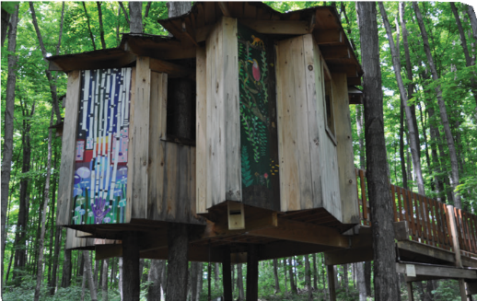
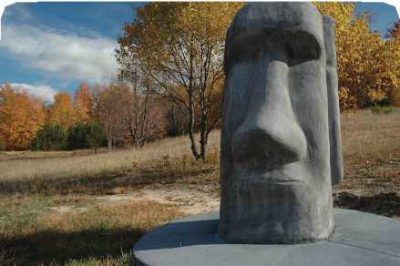
2022 Membership Form

DISCOVERY
CENTER
WHERE SCIENCE, HISTORY AND ART CONNECT
MEMBERSHIPS
All members receive: admission for one year, additional guest passes as noted below, personal satisfaction knowing that you support informal learning opportunities at Raven Hill Discovery Center, subscription to newsletter, invitations to receptions and special events and a 10% discount on gift shop items and classes (must show card).

Individual $50: Admission for one member + 1 guest pass

Family $100: Admission for a single household up to two adults and all children + 2 guest passes Grandparents $120: Admission for 2 adults and all grandchildren + 2 guest passes Generations $160: Admission for 3 generations of a family + 4 guest passes
Annual Fund Members

Discovery Circle $250: 2 members, 2 guests for any visit & all children

Sponsor Circle $500: Discovery Circle PLUS the opportunity to be a Day Sponsor* providing a day of free admission for visitors to Raven Hill.

Raven Circle $1000: 2 members and unlimited guests PLUS the opportunity to be a Day Sponsor* providing two days of free admission for visitors to Raven Hill

Military Discount: | $10 discount available on all regular memberships active duty and retired military personnel.
Teacher Discount: | $10 discount available on all regular memberships for current and retired school teachers.
Student Discount: | $10 discount available on individual memberships for students under 18 or with college ID.
* Day Sponsor/s: Your business information will be prominently displayed on site and online on your selected day(s). Contact us for more information.
Join and Renew Online! www.MiRavenHill.org/Memberships
(231) 536-3369 | 04737 Fuller Road, East Jordan, MI 49727 | www.MiRavenHill.org | info@miravenhill.org

2022 Membership Form

Name: Address:
City: State: Zip code:
Phone: Email: Address 2:
City: State: Zip code:
Months at address 2:
- I am a member of the military ☐ I am a student ☐ I am a current school teacher
Please check one:

 | Individual + 1 guest pass | $50
 | Family + 2 guest passes | $100
 | Grandparents + 2 guest passes | $120
 | Generations + 4 guest passes | $160
 | Discovery Circle | $250
 | Sponsor Circle | $500
 | Raven Circle | $1000

Check one: NEW RENEWING I’d like to make an additional gift of $
TOTAL AMOUNT INCLUDED: $_____________
Please send memberships payable to
Raven Hill Discovery Center 4737 Fuller Road
East Jordan, MI 49727
or pay online at www.MiRavenHill.org/memberships

OFFICE USE ONLY
Date purchased/renewed: Amount: | Check # CC: Cash
- Membership Card ☐Free Passes| Acknowledgement sent: ______________

