04737 Fuller Road, East Jordan, MI 49727
(231) 536-3369 |www.miravenhill.org info@miravenhill.org
Raven Hill Discovery Center is a 501(c)(3) tax-exempt corporation.
Mission: Raven Hill provides a place that enhances hands-on and lifelong learning for all ages by connecting science, history & the arts.

Photo Journal: Azalea & Rhododendron

June 8, 2020

Imagine spring in the mountainous regions of the United States, where the understory of the forests is a blanket of pink and purple azaleas and rhododendrons growing wild. Raven Hill’s rhododendron blooms after the Center’s azalea. Both can be found in front of the Fiber Studio. They were relocated from the front of Raven Hill, where snow sliding off the roof caused too much damage to them. Rhododendrons are a woody bush in the heath family and can be evergreen or deciduous. Raven Hill’s is evergreen. Rhododendrons are found in Europe, Russian and Asia, as well as the Pacific Northwest, California, and the highlands of the Appalachian Mountains of North America. It is the national flower of Nepal, as well as the state flower of Washington and West Virginia in United States. Most cultivated species have brightly colored flowers. In the Appalachians, the flowers are usually pink or purple. Azaleas are a subgenus of rhododendron. Rhododendrons are invasive in Ireland and the United Kingdom. They were introduced and have spread in woodland areas, replacing the natural understory. Rhododendrons were first described in the sixteenth century and at that point were called Chamaerhododendron (low-growing rose tree). Linnaeus included them in his Species Plantarum in 1753. He considered azalea a separate genus.

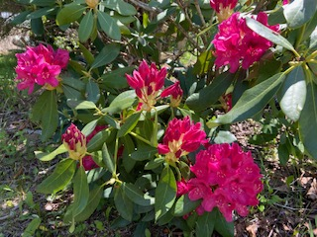
Raven Hill’s azalea in May 2020 (left) and rhododendron in June 2020 (right)

