04737 Fuller Road, East Jordan, MI 49727

(231) 536-3369 |[www.miravenhill.org](http://www.miravenhill.org/) [info@miravenhill.org](mailto:info@miravenhill.org)

*Raven Hill Discovery Center, incorporated in 1991, is a 501(c)(3) tax-exempt corporation.*

**Mission:** Raven Hill provides a place that enhances hands-on and lifelong learning for all ages by connecting science, history & the arts.

To: Friends and Family Everywhere From: Cheri and Raven Hill

Date: June 5, 2021 Re: Weekly Update

Greetings Everyone!

Today, we use rulers or measuring tapes to determine the length of objects. Historically, body parts were used to measure things. Because everyone is a little different in size, the measurements weren’t always exact, but they were close enough for most situations. In fact, we still use a measurement today that is a body part—the foot. Our foot unit of measurement today is now a “standardized” unit. Another old measurement is the uncia, which is the Roman word for the distance between two joints on a finger or about 1”. A hand is the width of a hand, which is now standardized to 4 inches. Horses are still measured in hands. For example, a horse might be 16 hands high.

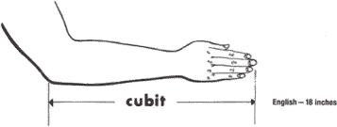

My favorite old measurement is a cubit, which is the distance from your elbow to tip of your middle finger. That length is about 18” on most adults. Noah was given the measurements for the ark in cubits and the Egyptians used cubit measurement to build the pyramids.

*My cubit is 17 inches long, but it works perfectly well for me. Measure your cubit. Then, try using your cubit to measure something!*

I use cubits at lot. I’m always measuring Checkers, the corn snake, in cubits. Checkers is greater than two cubits. At home,

when I am rearranging the furniture, I can use my cubit to determine if the couch will fit in a new space easily, if the couch is too long OR if it’s close and I probably should go find a measuring tape!

Raven Hill finished up its **STEM Plus** outreach program this week. Thanks to grant awards from the Charlevoix County and Petoskey- Harbor Springs Area Community Foundations, Charlevoix and Emmet County students added History and Language Arts to Science, Technology, Engineering and Mathematics (STEM). Using a variety of measuring tools, these student engineers followed the advancement in the technology of tools and the history of measurement from ancient to modern times. Over time, certain tools were created to make measuring distance easier. During this **STEM Plus** activity, the students measured a brick wall in “student” cubits and they also determined the length of the same wall with a carpenter rule, measuring tape, iPhone measuring app and a laser measurer, all for comparison.

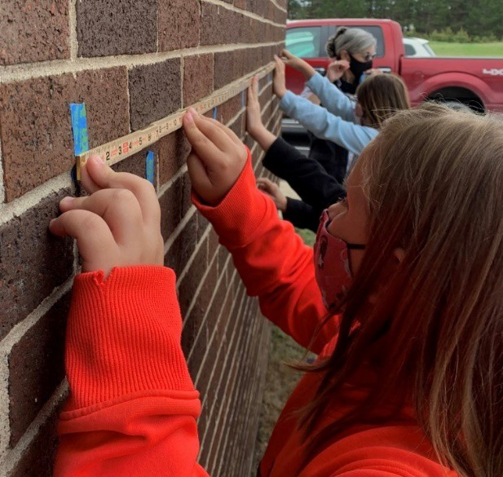

*Pellston fourth graders are using a carpenter rule to measure the length of the brick wall. These folding or zigzag rulers have been used since the mid-1800’s. Do you remember your Grandfather using one?*

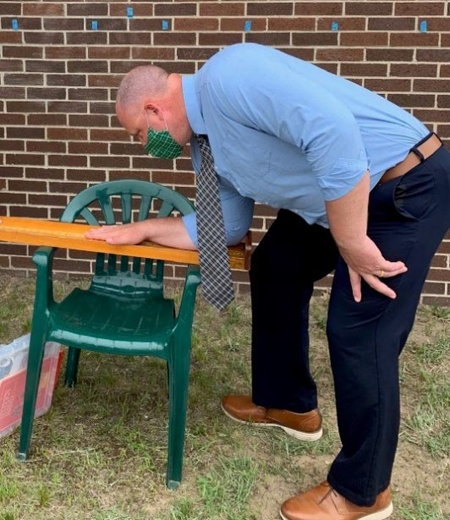Each teacher and all students got to measure their own cubit. At the end of the lesson, everyone was given two homework assignments. First, they were asked to use their communications or language arts skills to explain to an adult or older sibling a little about cubits and their history. Their second task was to apply their new math skills to measure the length of their table at home both in cubits and feet.

In ancient times, each civilization had their own cubit measurement. There was an Egyptian, [Indus Valley](https://en.wikipedia.org/wiki/Indus_Valley) and Mesopotamian cubit, which were used in the 3rd millennium BCE (formerly BC). Cubits are the first known units used to measure length. The Long or Royal Cubit was a standard cubit plus an extra palm and was used in constructing buildings and monuments and in surveying in ancient Egypt.

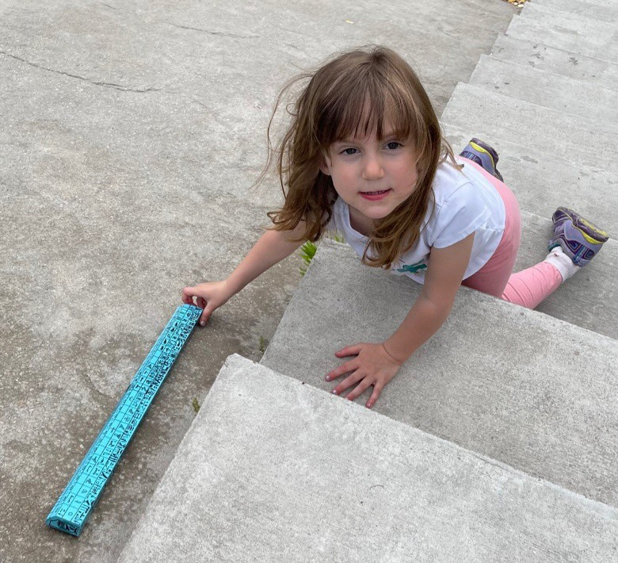

*This bright blue Egyptian royal cubit replica has hieroglyphics all*

*over it! It is easy to use and is available to check out and use here*

*at Raven Hill. Or, you always have your cubit with you ready to use!*

*Pellston Superintendent, Steve Seelye’s cubit measured 22*

*inches. That is longer than a royal or long cubit!*

*By the way, which is the better deal? Should you buy a wooden board for $.50 per cubit or $.50 per royal cubit?!*

Here at Raven Hill, Emily used a royal cubit (21 inches) to measure the Pyramid out in the Center’s Ancient World. The Egyptians would tie knots in a long rope at “cubit” intervals. That way, they could stretch out the rope and count the cubits or knots to easily determine a longer distance.

The Dinosaur Height Chart in the new **Connections Trail** will have a carpenter rule on one side and a rope with knots tied at each cubit on the other, so that kids and adults can measure their height and compare it to the dinosaurs!

With the new learning stations soon to be installed along the **Connections Trail**, there will be other opportunities to measure all matter of things, like temperature, rainfall, wind speed and paces!

Raven Hill is now open daily! Regular hours are noon to 4pm on Saturdays, 2pm to 4pm on Sundays, 10am to 4pm weekdays and other times by appointment. Email [info@miravenhill.org](mailto:info@miravenhill.org) or call 231.536.3369 for questions or to make reservations. COVID policies remain in place for the time being. For the sake of the children, we ask everyone to wear masks inside, socially distance & wash their hands.

Take care. **Cheri**

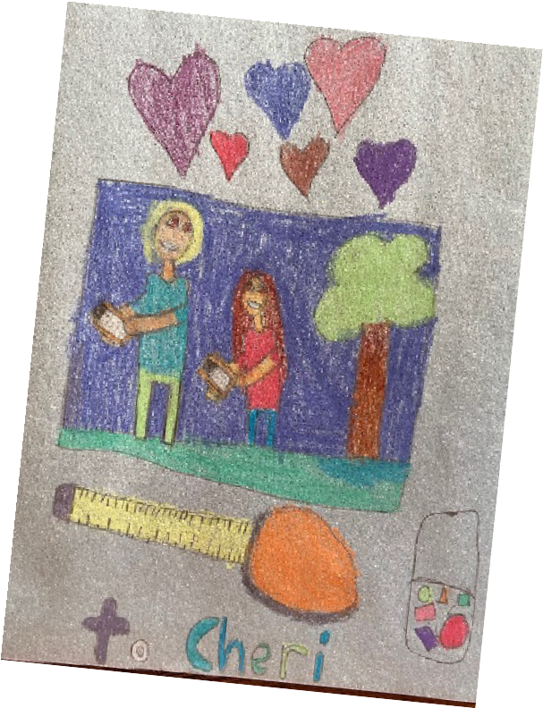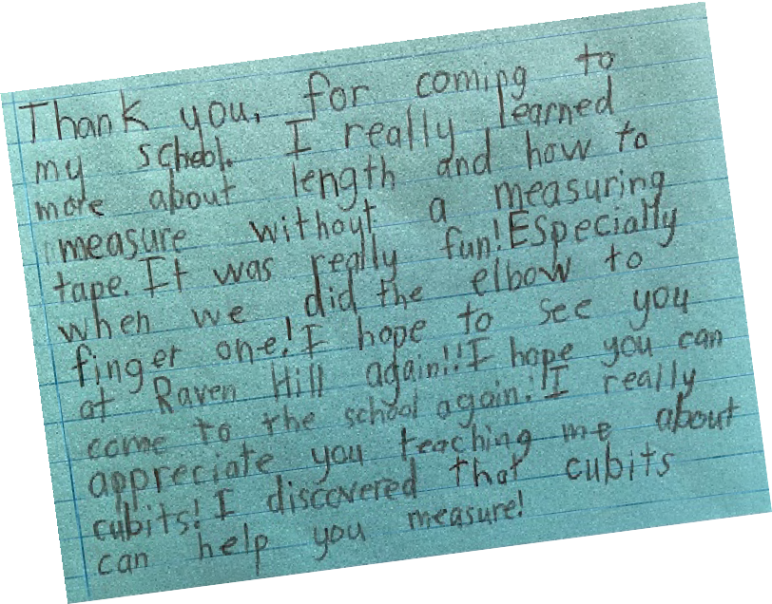

PS—It is always fun to hear from students, after I visit their school. I love going to the mailbox and finding a thick Manila envelope full of handwritten notes and pictures from students!

This picture and note perfectly captured the focus of the lesson. In Boyne Falls, thanks to one teacher’s quick thinking, STEM became STEAM as the creativity of art was added to the student **STEM Plus** experience.